**CSD2500 Report**

**By Vishvak Baskaran M00652690**  
  
Structural element tags are tags used in HTML which contain a specific set of information or metadata in a web page. There are various types of structured element tags used over the course of my HTML code.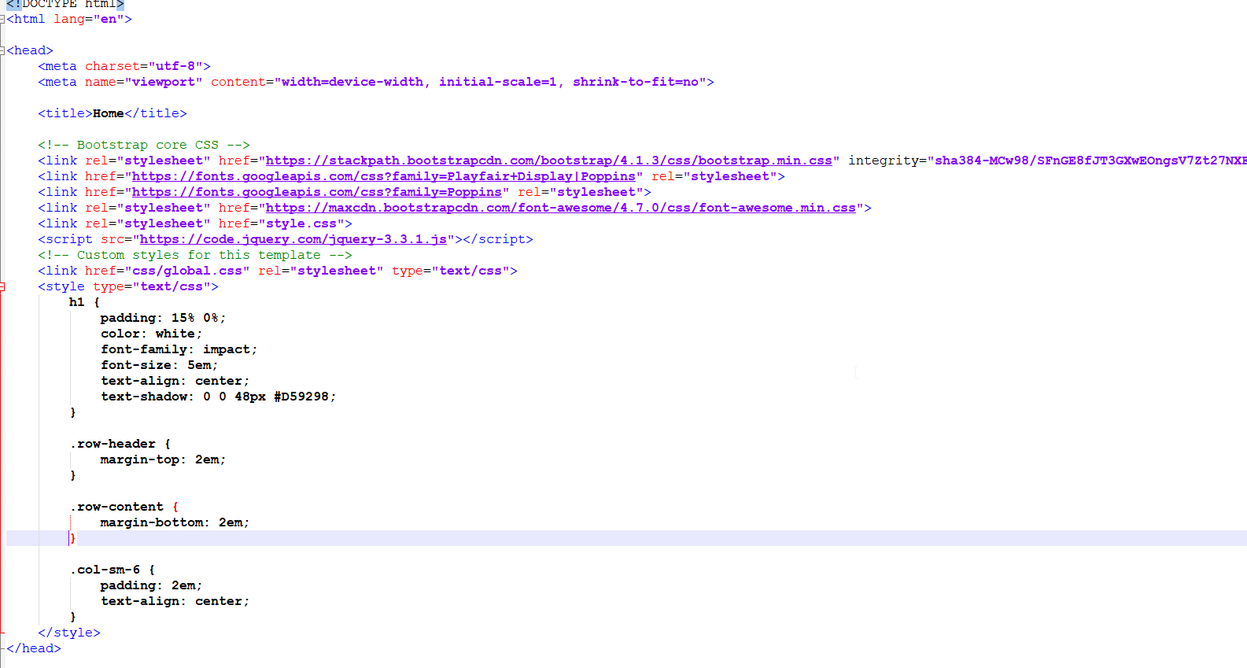

In this set of code I introduced the <header> tag which is a structural element tag that provides a container of introductory content or a set of navigational links which help define my web page.

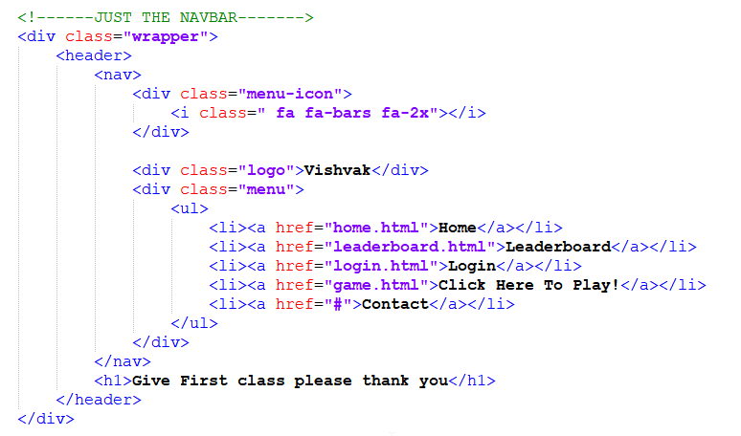

In this block of code I have used the structural element of <nav> which helps define a set of navigational links on the menu which the user can migrate too.

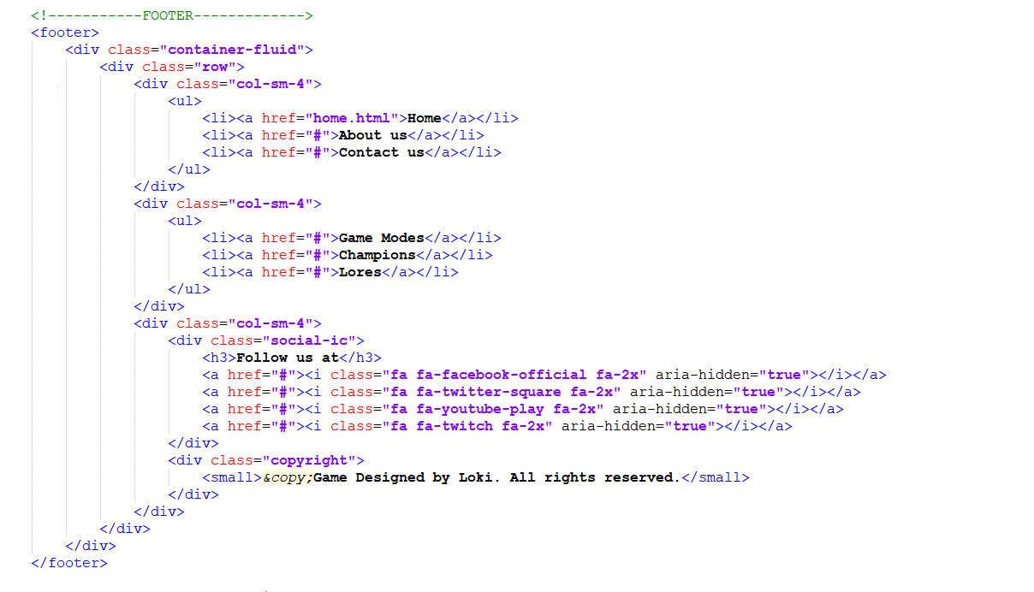

In this block of code, the structural element used here is <footer> which contains information about its containing elements. Generally, the type of information a footer usually contain are authorship information, copyright information, contact information etc..

A HTML content element tag must have a starting tag as well as an ending tag. The content which is to be provided on the website is usually set between the start and the end tag.  
  
There are many content tags used in my Game website to provide content such as game information, contact details, game modes etc.  
  
  
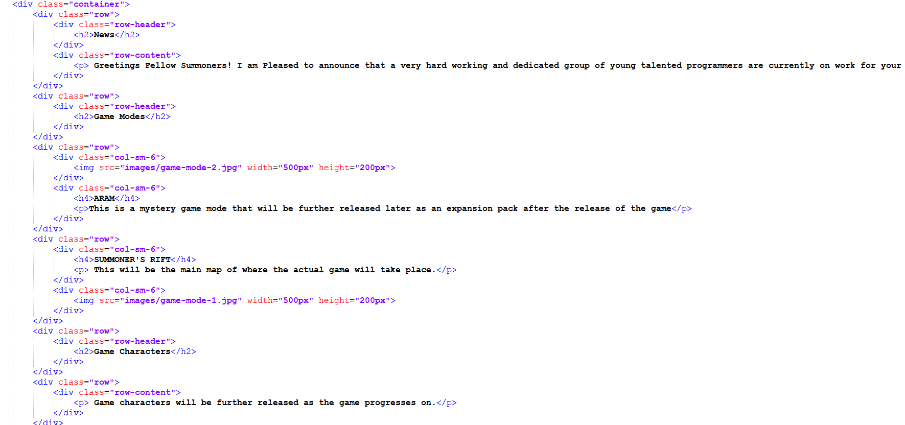

In this specific block of code, the <h1> <h2> tags denote the headings and the <div> tag denotes divisions. The <p> tag consists of a paragraph where I describe the game and its contents to the user.   
These specific tags are used to provide content to users on my webpage.

The class attribute in HTML is used to specify one more class names in an element. It is usually used to point to a class attribute on a Style sheet.

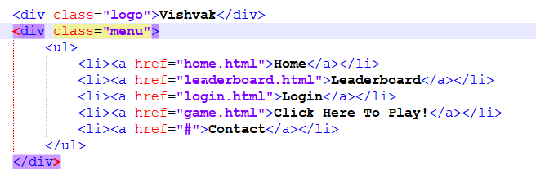

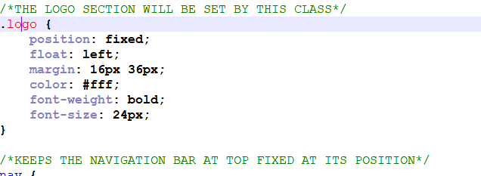

In the above two screenshots I have used a class as part of my logo and the first screenshots shows the styling, I have used for my Logo class.

The class attribute is used to define equal styles for elements which contain the same class name so all HTML elements with the exact class attribute will contain the exact class format and style.

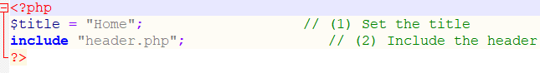

The php function name for this is include it imports the header.php file which allows it to access all pre-define variables and functions. This could have unintended consequence's if a file is included more than once.

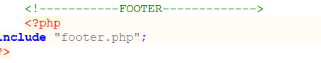

The php function name for this is include it imports the footer.php file which allows it to access all pre-define variables and functions. This could also consist of unintended consequence’s if a file is included more than once.

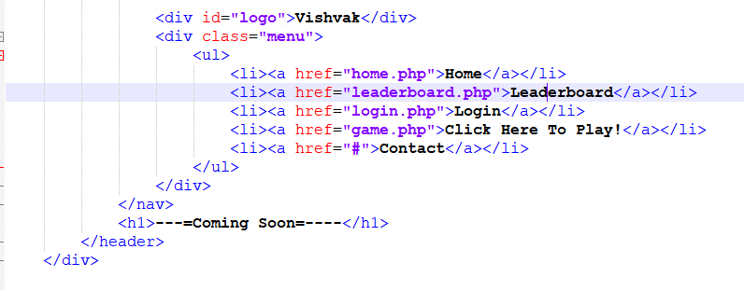

The Id attribute on the other hand helps to specify a unique id for an HTML element. The Id element is used to point to a style on the Style sheet.

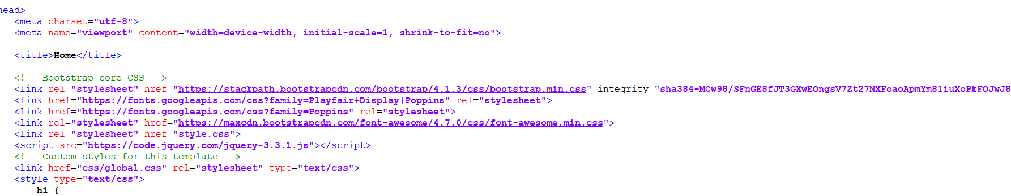

The third-party library I used in my project is Bootstrap. Bootstrap is free front-end framework for a more efficient method of web development. I found using bootstrap was a lot easier than using CSS grid.

Some of the key main reasons why I have implemented bootstrap as a third party library as opposed to CSS grid is because of its easy to use features, browser compatibility and its responsive features.

The bootstrap CDN website consists of a faster loading time because it is loaded from the cache as many people use bootstrap CDN.

The library feature which I have implemented is grid. Bootstraps grid system allows up to 12 columns across the page. The bootstrap grid system consists of 4 grids. Xs for phones, sm for tablets, md for small laptops, and lg for most laptops and desktops.

Bootstrap also requires a containing element to wrap site content there are generally two to choose from. They are .container class which provides responsive fixed width container and .container fluid class which provides a full width container, spanning the entire width of viewport.  
  
In my project I have only used .container.